### **Write the python program to implement Decision Tree**

### **AIM**

To implement a simple **Decision Tree classifier** in Python without external libraries, using **Gini Index** as the splitting criterion.

### **Algorithm**

1. **Node Structure**
   1. Each node stores feature, threshold, left child, right child, and class value (if leaf).
2. **Gini Index Calculation**
   1. For a given split, calculate impurity = *1−∑p21 - \sum p^2*1−∑p2, where *pp*p is the class proportion.
3. **Splitting**
   1. Try all possible feature values as thresholds.
   2. Select the split with the **minimum Gini Index**.
4. **Recursive Tree Building**
   1. Stop if:
      1. All samples are of one class (pure leaf).
      2. Maximum depth is reached.
      3. No valid split found.
   2. Otherwise, split into left and right subtrees.
5. **Prediction**
   1. Traverse the tree: if value at leaf, return it.
   2. Otherwise, check feature value against threshold and recurse left/right.

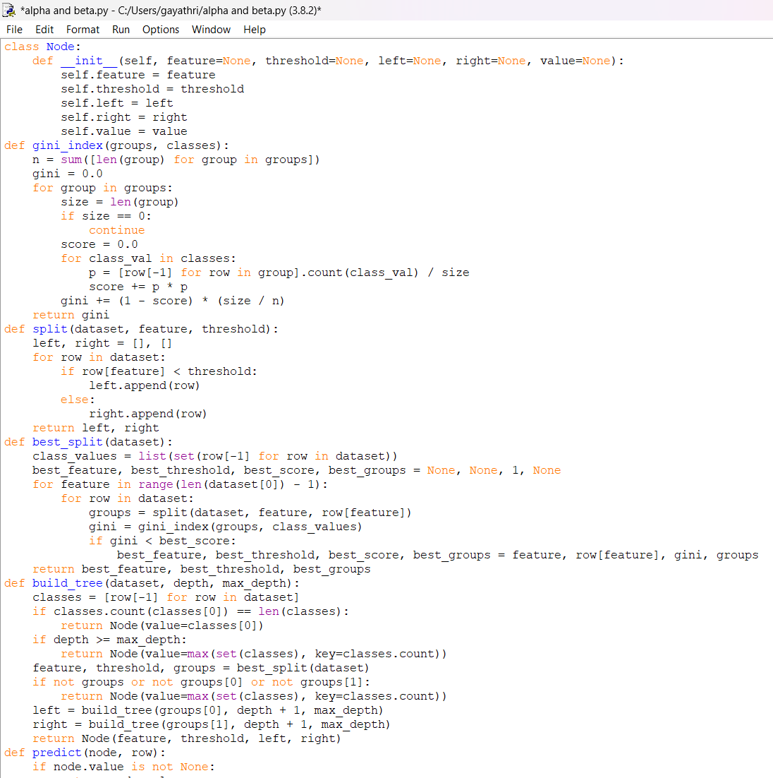

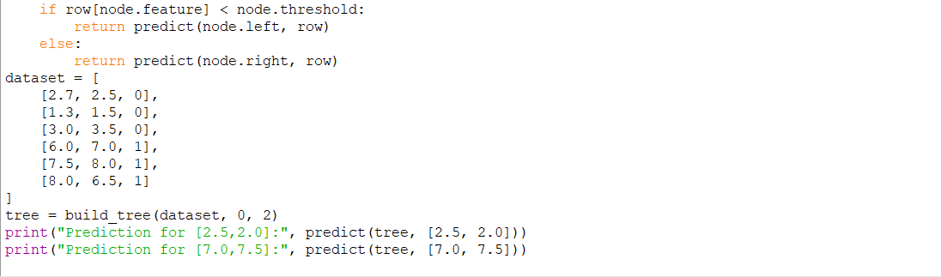

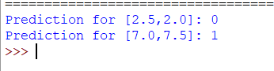

### **Result / Output**

Input dataset (2D points with labels 0 or 1):